Tutorial – 8.1

**Aim:** Write a shell script to check entered string is palindrome or not.

**Code:**#!/bin/bash

echo "Enter a string:"

read input_string

reversed_string=$(echo "$input_string" | rev)

if [ "$input_string" = "$reversed_string" ]; then

echo "The string '$input_string' is a palindrome."

else

echo "The string '$input_string' is not a palindrome."

fi

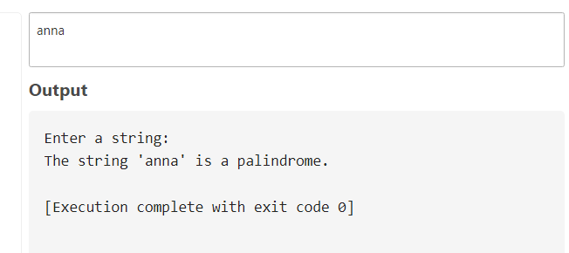**Output:**